1. **Why is Continuous monitoring necessary?**

I will suggest you go with the below mentioned flow:  
Continuous Monitoring allows timely identification of problems or weaknesses and quick corrective action that helps reduce expenses of an organization. Continuous monitoring provides solution that addresses three operational disciplines known as:

* continuous audit
* continuous controls monitoring
* continuous transaction inspection

**Q2. What is Nagios?**

You can answer this question by first mentioning that Nagios is one of the monitoring tools. It is used for Continuous monitoring of systems, applications, services, and business processes etc in a DevOps culture. In the event of a failure, Nagios can alert technical staff of the problem, allowing them to begin remediation processes before outages affect business processes, end-users, or customers. With Nagios, you don’t have to explain why an unseen infrastructure outage affect your organization’s bottom line.  
Now once you have defined what Nagios is, you can mention the various things that you can achieve using Nagios.  
By using Nagios you can:

* Plan for infrastructure upgrades before outdated systems cause failures.
* Respond to issues at the first sign of a problem.
* Automatically fix problems when they are detected.
* Coordinate technical team responses.
* Ensure your organization’s SLAs are being met.
* Ensure IT infrastructure outages have a minimal effect on your organization’s bottom line.
* Monitor your entire infrastructure and business processes.

This completes the answer to this question. Further details like advantages etc. can be added as per the direction where the discussion is headed.

**Q3. How does Nagios works?**

I will advise you to follow the below explanation for this answer:  
Nagios runs on a server, usually as a daemon or service. Nagios periodically runs plugins residing on the same server, they contact hosts or servers on your network or on the internet. One can view the status information using the web interface. You can also receive email or SMS notifications if something happens.  
The Nagios daemon behaves like a scheduler that runs certain scripts at certain moments. It stores the results of those scripts and will run other scripts if these results change.

Now expect a few questions on Nagios components like Plugins, NRPE etc...

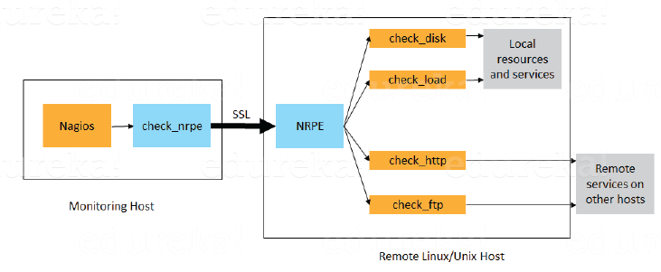

**What is nagios?**

Nagios monitors your entire IT infrastructure to ensure systems, applications, services, and business process are functioning properly.

Why we need continuous monitoring

1. Failure of ci/cd pipeline
2. Rapid introduction of errors
3. Rapid introduction of new end points causing monitoring issues.
4. Lengthy root cause analysis as the number of services end points.

It resolves that any sat of errors regarding memory speed analyses, etc